

**Shoppy E-Commerce Website**

A PROJECT REPORT

**Submitted by:**

**Vishal Kumar**

**Btech-CSE**

**Section: K**

**University Roll No. : 2115001127**

**Dhruv sharma**

**Btech-CSE**

**Section:K**

**University Roll No. : 2115000363**

**Submitted To:**

**Mrs. Gurpreet Kaur**

**Technical Trainer**

**Computer Engineering and Applications**

**GLA University,Mathura**

**Candidate's Declaration**

I hereby declare that the work, which is being presented in the Project Report, entitled " **Shoppy E-Commerce Website**" in partial fulfilment for the award of Degree of "Bachelor of Technology" in Deptt. Of Computer Science and Engineering and submitted to the Department of Computer Science and Engineering, GLA University, is a record of my team investigations carried under the Guidance of **Mrs. Gurpreet Kaur** Department of Computer Science and Engineering,GLA University.

Vishal Kumar

University No.: 2115001127

Dhruv Sharma

University No.: 2115000363

GLA University

**ACKNOWLEDGEMENT**

It is my pleasure to be indebted to various people, who directly or indirectly contributed in the development of this work and who influenced our thinking, behavior and acts during the course of study.

We are thankful to **Mrs. Gurpreet Kaur (**Department of Computer Science and Engineering,GLA University**)** for his support, cooperation, and motivation provided to us during the training for constant inspiration, presence and blessings.

Lastly, we would like to thank the almighty and our parents for their moral support and friends with whom we shared our day-to-day experience and received lots of suggestions that improved our quality of work.

Vishal Kumar

University No.: 2115001127

Dhruv Sharma

University No.: 2115000363

GLA University

**ABSTRACT**

Our project is Shoppy E-Commerce website. This is a website which helps students to find and buy all type of watches on internet. It is useful in the way that it makes an easier way to buy and sell watches online.

Shoppy E-Commerce website is an interactive e-commerce solution providing users with an opportunity to buy and sell watches. Shoppy E-Commerce website is the online platform which deals with new watches.

In this website we have basically 2 modules. The first module includes the customer module and second module includes admin module.

The customer have to register for any enquiry related to watches. The registered customer can view details of watches and he/she can buy or sell the watches of his/her need. He/she has to pay and will get home delivery.

The admin module contains the access of admin page on the website. The admin can change everything in the website. He have the ability to add, delete, and update any information regarding the watches.

# INDEX

|  |  |
| --- | --- |
| **S.No.** | **Contents** |
| **1.** | Introduction |
| **2.** | WEB-DEVELOPMENT |
| **3.** | THE STEPS TO CREATE A WEB SITE |
| **4.** | Technologies Used |
| **5.** | Screenshot |
| **6.** | FUTURE SCOPE & FUTURE ENHANCEMENT |
| **7.** | Conclusion |

**Chapter 1**

**INTRODUCTION**

Electronic commerce or e-commerce refers to a wide range of online business activities for products and services. It is usually associated with online buying and selling over the internet or conducting any transaction involving the transfer of ownership or rights to use goods or services through a computer mediated network. In our eyes we see it as a new dimension to the varied use of the internet and our purpose is to make it trendy in our country where its use is particularly very low. Because of the high context culture it is very important to develop trust among the people interested in a transaction. E-commerce in Bangladesh actually started in the year of 1999 based in USA with some non-resident Bangladeshis. Our motto is to develop an enriched e-commerce website in our country that should be largely accepted by the customers.

**1.1 OBJECTIVES**

Online Shopping is the process whereby consumers directly buy goods and services without any intermediary service over the internet. The goal of this website is to develop a web based interface for people, the website would be easy to use and hence the shopping experience pleasant for the users. The main goal of this website is:

I. To develop an easy to use web based interface where a person can search for products (watches), view a complete description of the product and order the product.

II. A person can buy watches from home.

**CHAPTER-2**

**WEB-DEVELOPMENT**

Web development is a broad term for the work involved in developing a web site for the Internet (World Wide Web) or an intranet (a private network). Web development can range from developing the simplest static single page of plain text to the most complex web-based internet applications, electronic businesses, and social network services. A more comprehensive list of tasks to which web development commonly refers, may include web engineering, web design, web content development, client liaison, client-side/side scripting, web server and network security configuration, and e-commerce development. Among web professionals, "web development" usually refers to the main non-design aspects of building web sites: writing markup and coding. Most recently Web development has come to mean the creation of content management systems or CMS. These CMS can be made from scratch, proprietary or open source. In broad terms the CMS acts as middleware between the database and the user through the browser. A principle benefit of a CMS is that it allows non-technical people to make changes to their web site without having technical knowledge.

For larger organizations and businesses, web development teams can consist of hundreds of people (web developers) and follow standard methods like Agile methodologies while developing websites. Smaller organizations may only require a single permanent or contracting developer, or secondary assignment to related job positions such as a graphic designer or information systems technician. Web development may be a collaborative effort between departments rather than the domain of a designated department. There are three kind of web developer specialization: front-end developer, back-end developer, and full-stack developer.

**2.1 WEB-SITE**

A website is a collection of related web pages, including multimedia content, typically identified with a common domain name, and published on at least one web server. A website may be accessible via a public Internet Protocol (IP) network, such as the Internet, or a private local area network (LAN), by referencing a uniform resource locator (URL) that identifies the site.

Websites have many functions and can be used in various fashions; a website can be a personal website, a commercial website for a company, a government website or a non-profit organization website. Websites are typically dedicated to a particular topic or purpose, ranging from entertainment and social networking to providing news and education. All publicly accessible websites collectively constitute the World Wide Web, while private websites, such as a company's website for its employees, and are typically a part of an intranet.

Web pages, which are the building blocks of websites, are documents, typically

composed in plain text interspersed with formatting instructions of Hypertext Markup

Language (HTML, XHTML). They may incorporate elements from other websites with suitable markup anchors. Web pages are accessed and transported with the Hypertext Transfer Protocol (HTTP), which may optionally employ encryption (HTTP Secure, HTTPS) to provide security and privacy for the user. The user's application, often a web browser, renders the page content according to its HTML markup instructions onto a display terminal.

Hyperlinking between web pages conveys to the reader the site structure and guides the navigation of the site, which often starts with a home page containing a directory of the site web content. Some websites require user registration or subscription to access content. Examples of subscription websites include many business sites, news websites, academic journal websites, gaming websites, file-sharing websites, message boards, web-based email, social networking websites, websites providing real-time stock market data, as well as sites providing various other services. As of 2016 end users can access websites on a range of devices, including desktop and laptop computers, tablet computers, smartphones and smart TVs.

A web site consists of web pages which are interconnected to each other and contain various data and functionalities.

**2.2 WEB-PAGE**

A web page, or webpage, is a document that is suitable for the World Wide Web and web browsers. A web browser displays a web page on a monitor or mobile device. The web page is what displays, but the term also refers to a computer file, usually written in HTML or comparable markup language. Web browsers coordinate the various web resource elements for the written web page, such as style sheets, scripts, and images, to present the web page.

Typical web pages provide hypertext that includes a navigation bar or a sidebar menu to other web pages via hyperlinks, often referred to as links.

On a network, a web browser can retrieve a web page from a remote web server. On a higher level, the web server may restrict access to only a private network such as a corporate intranet or it provides access to the World Wide Web. On a lower level, the web browser uses the Hypertext Transfer Protocol (HTTP) to make such requests.

A static web page is delivered exactly as stored, as web content in the web server's file system, while a dynamic web page is generated by a web application that is driven by server- side software or client-side scripting. Dynamic website pages help the browser (the client) to enhance the web page through user input to the server.

**CHAPTER-3**

**THE STEPS TO CREATE A WEB SITE**

Creating a web site requires multiple steps which includes the following:

* Creating a UI(User interface).
* Scripting(Both at server end and client end).
* Creating a backend or the database.

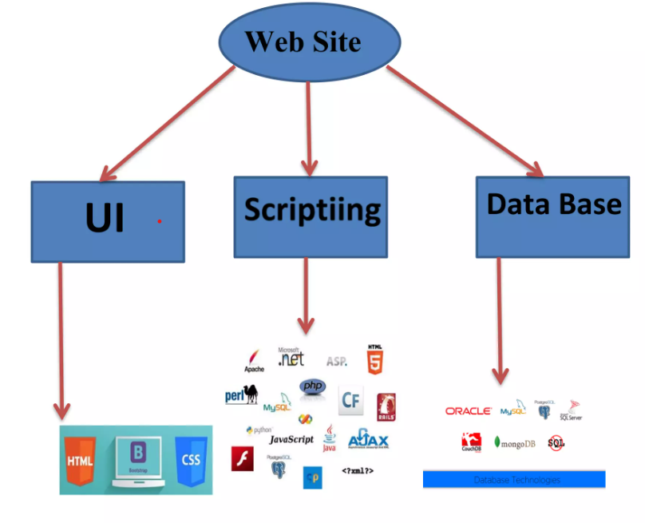

**CHAPTER-4**

**PROJECT**

**4.1 PROJECT (Advanced Technologies):**

Name: Shoppy E-Commerce website

**4.2 Technologies Used:**

➤ HTML

➤ CSS

➤ Bootstrap

➤ Core PHP

➤ Java Script

➤ Jquer

Server: Apache (XAMPP)

Database: MySql

Operating System: Windows7/8/8.1/10

**4.3 TECHNICAL DETAILS:**

➤ Front end is designed using HTML, CSS and Bootstrap.

➤ Backend is based on MySql based RDB(Relational Data Base) model.

> The SQL queries are run using the CI SQL library functions

> Backend online host includes a centralized database resident on the server, the script which is built in PHP used to SQL query the database on user's request for

transaction of data

The forms are made using the HTML, Bootstrap for designing and Php, sql for back-end

JavaScript, AJAX and JQuery used for client side scripting and PHP for the server side development.

**CHAPTER-5**

**SCREENSHOTS**

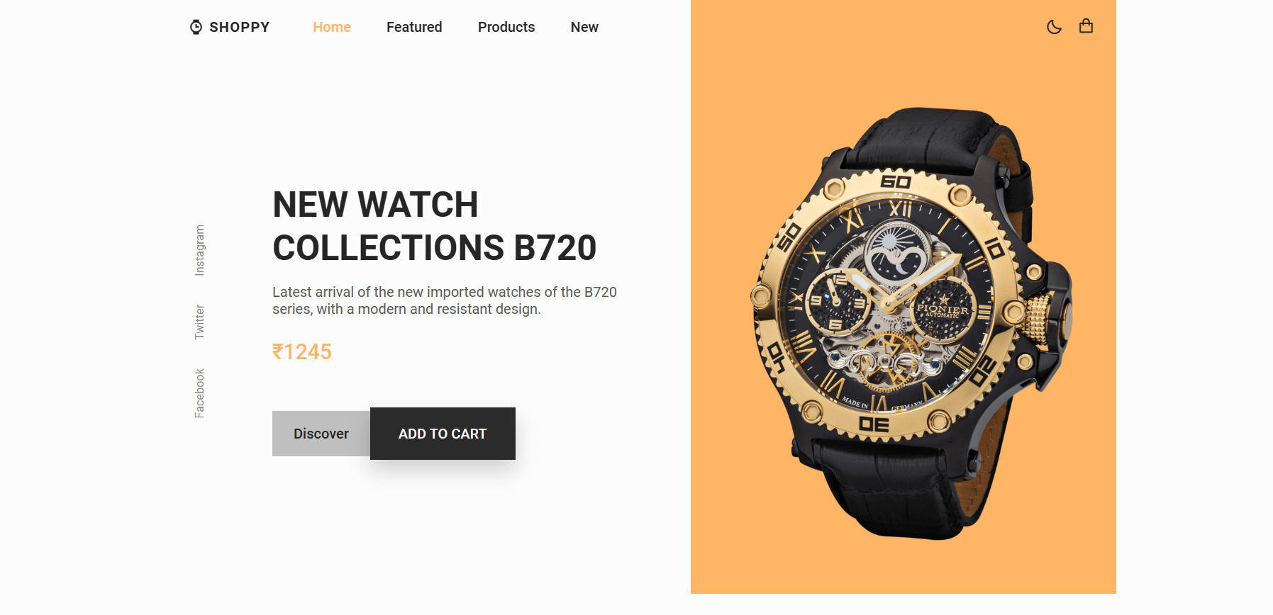

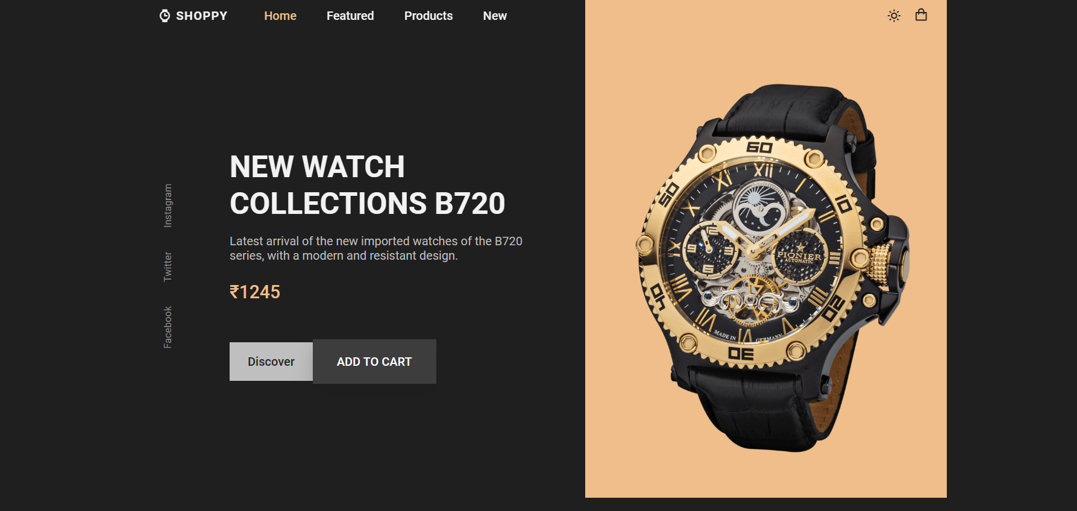

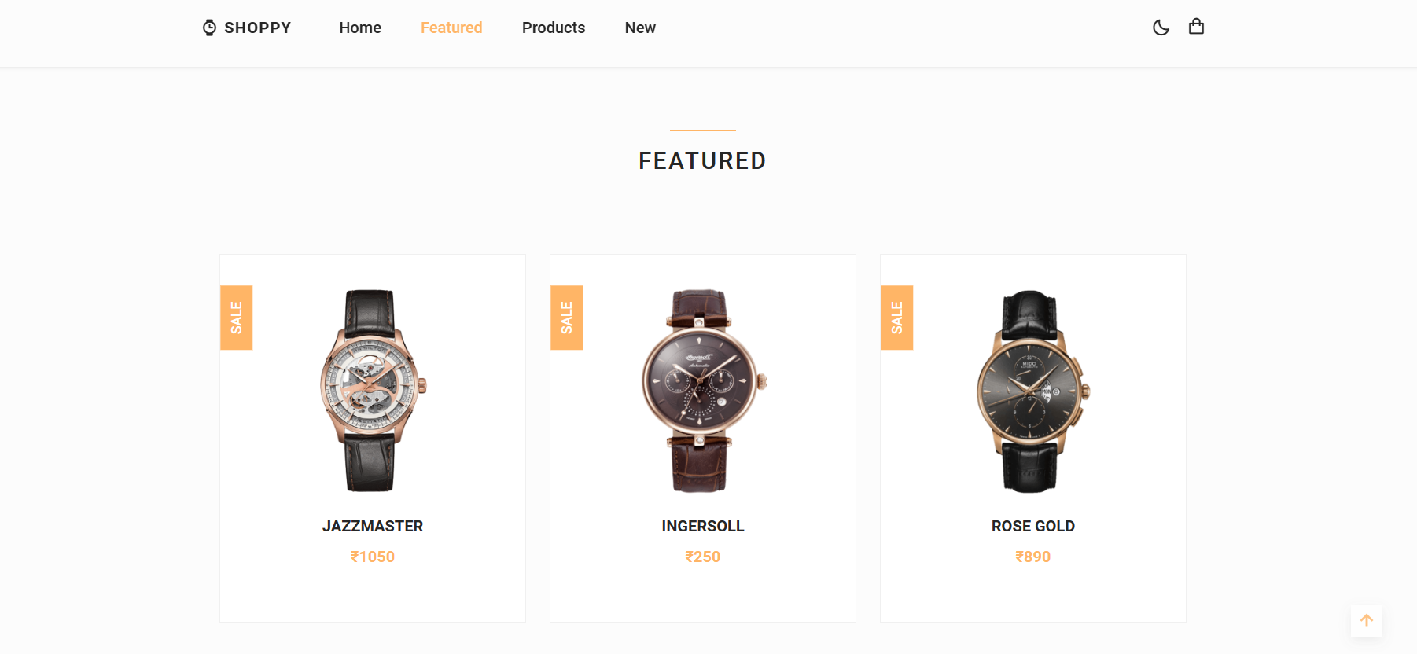

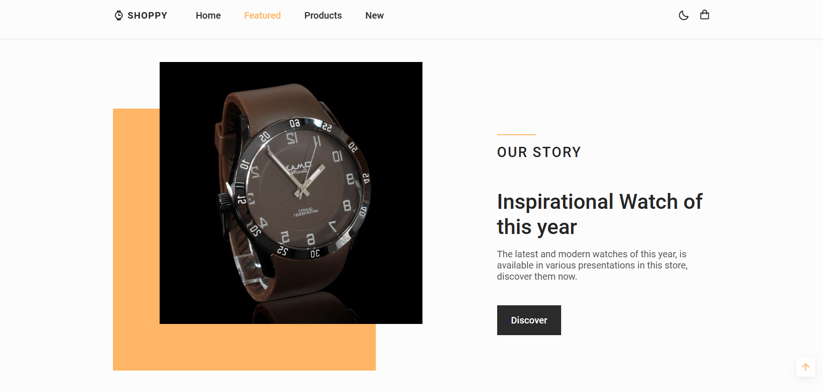

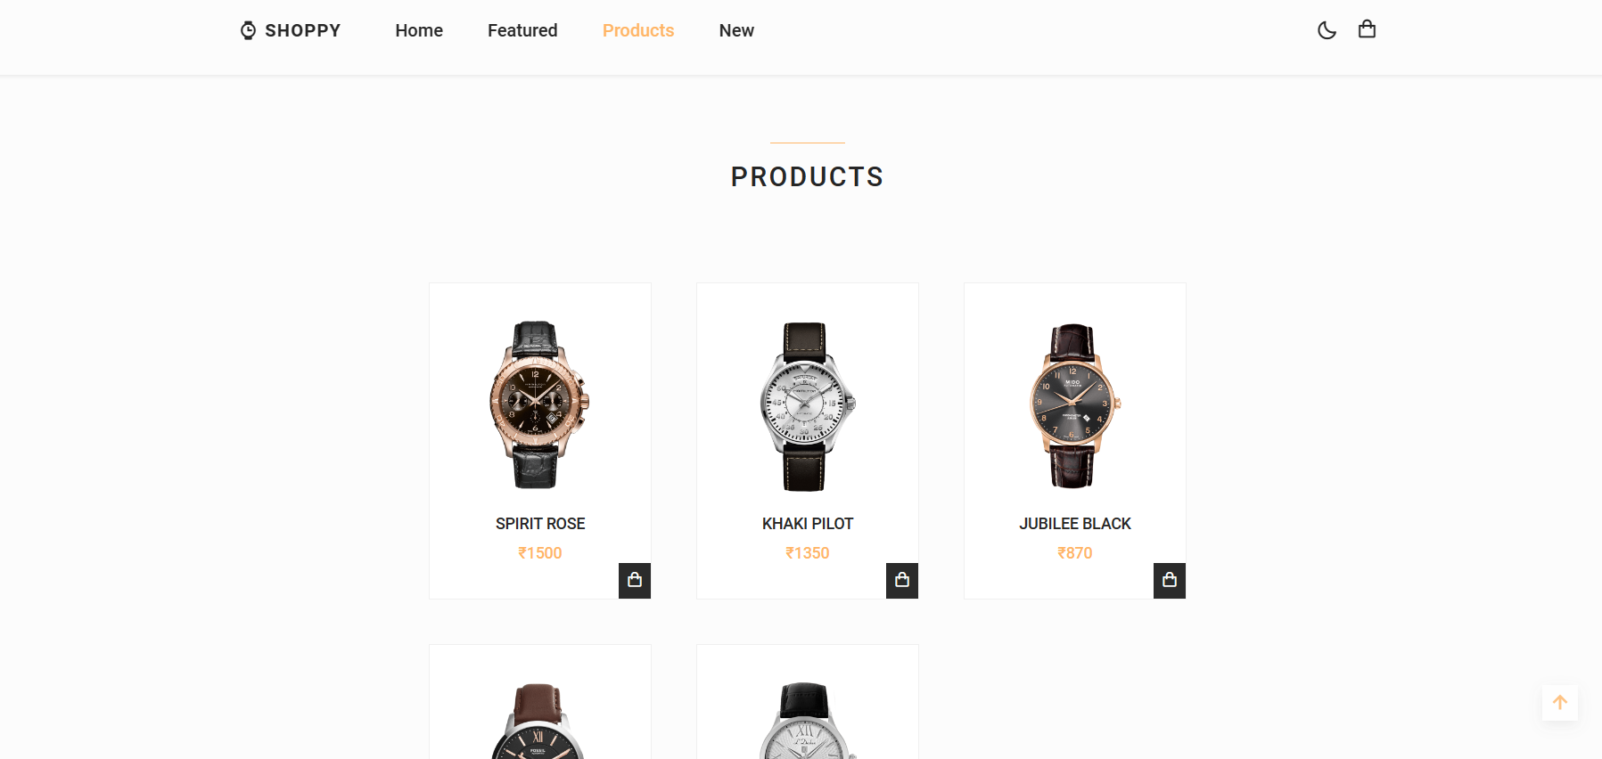





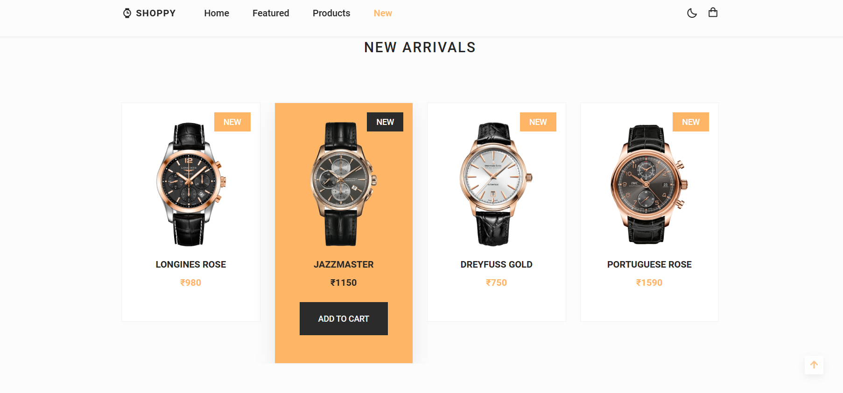



**CHAPTER-6**

**FUTURE SCOPE & FUTURE ENHANCEMENT**

PROJECT NAME: Shoppy E-Commerce website

1. Shoppy E-Commerce website would help each and every person to find any watches via our website and get it at home it will save their time.

2. It would provide huge collection of watches.

4. We will be providing some special watches for Gifts.

**CHAPTER-7**

**CONCLUSION**

We have successfully implemented the site‘Shoppy E-Commerce website’. With the help of various links and tools, we have been able to provide a site which will be live soon and running on the web. We have been successful in our attempt to take care of the needs of both the user as well as the administrator. Finally we hope that this will go a long way in popularizing.

**BIBLIOGRAPHY**

1. www.javatutpoint.com

2. www.w3schools.com

3. www.getbootstrap.com

4. www.stackoverflow.com

5. Head first with PHP(Lynn Beighley and Michael Morrison)

6. Learn HTML and CSS faster(Mark Myers)

7. Wikipedia